Project Report – Property Management Application

1.Introduction

1.1 Our Project is concerned to develop an app for Property Management where buyer can order his requirements and get the appropriate details.

1.2 The purpose of building this app is to make the property management of those in need convenient and easier by providing the best information.

Problem Definition and Design Thinking

2.1 Empathy Map

2.2 Ideation and Brainstorming

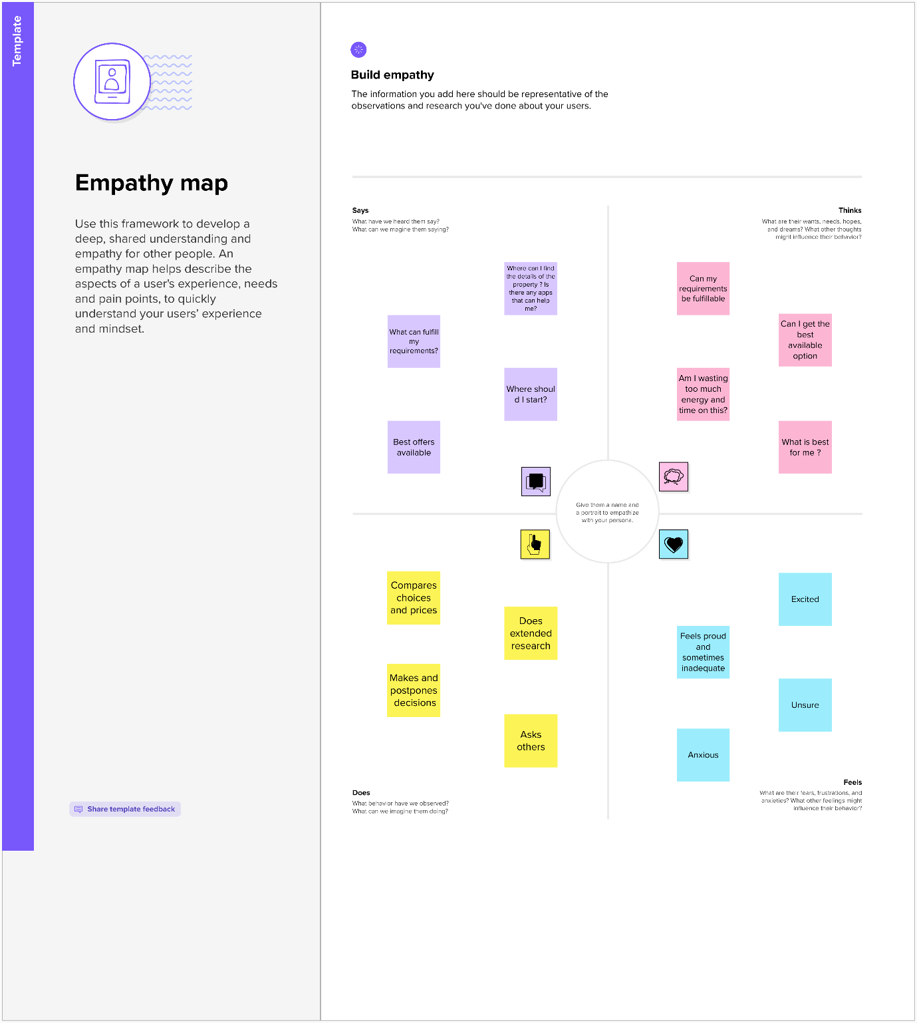

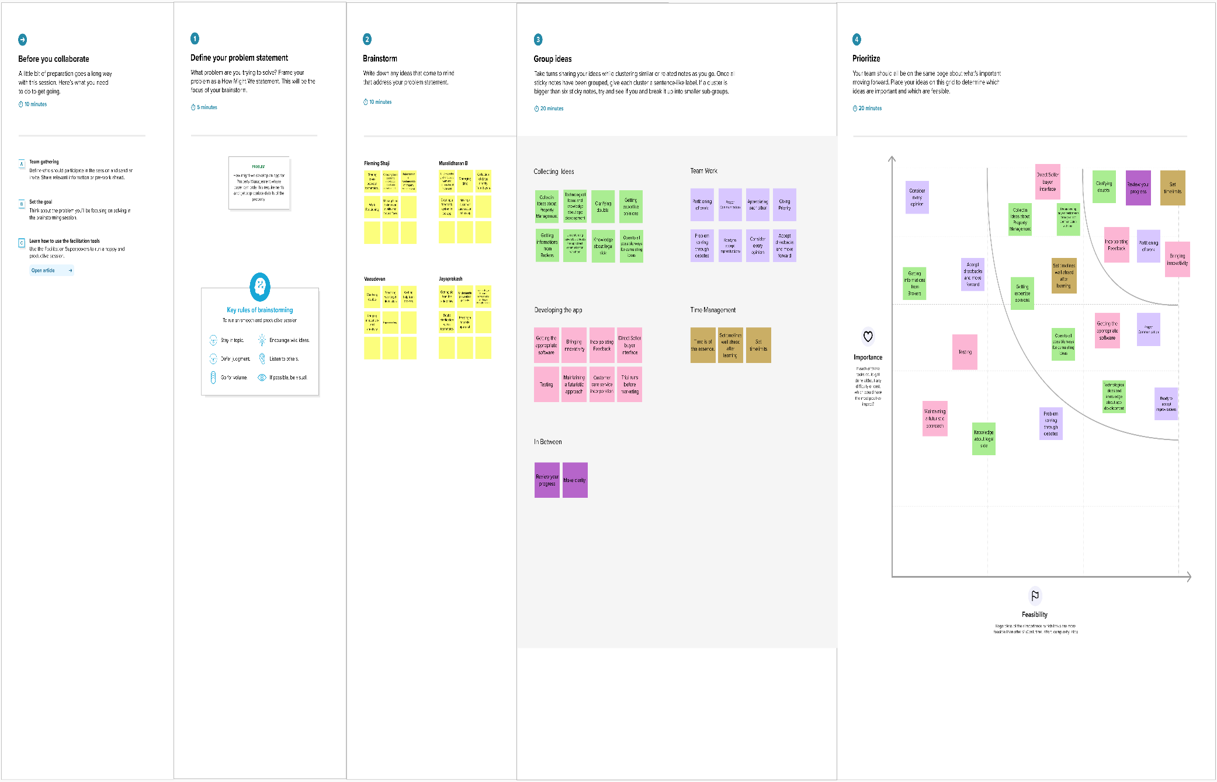

Result

3.1 Data Model

|  |  |
| --- | --- |
| OBJECT NAME | FIELDS IN THE OBJECT |
| LEAD | |  |  | | --- | --- | | FIELD LABEL | DATA TYPE | | LEAD | Auto number | | State | Picklist | | City | Picklist | | Email | Email | | Phone | Phone | |
| BUY | |  |  | | --- | --- | | FIELD LABEL | DATA TYPE | | Buy | Percent | | Property Type | Picklist | | Discount | Percentage | | State | Picklist | | City | Picklist | | Annual Amount to be Paid | Number | |
| RENT | |  |  | | --- | --- | | FIELD LABEL | DATA TYPE | | Rent | Auto Number | | Rental City | Text | | BHK Type | Picklist | |
| LOAN | |  |  | | --- | --- | | FIELD LABEL | DATA TYPE | | Loan ID | Auto Number | | Interest Rate | Percentage | | Term | Number | | Annual Loan | Number | | Total Loan Installments | Number | | Loan Repayment | Number | | Loan Amount | Formula | |

3.2Activity and Screenshot

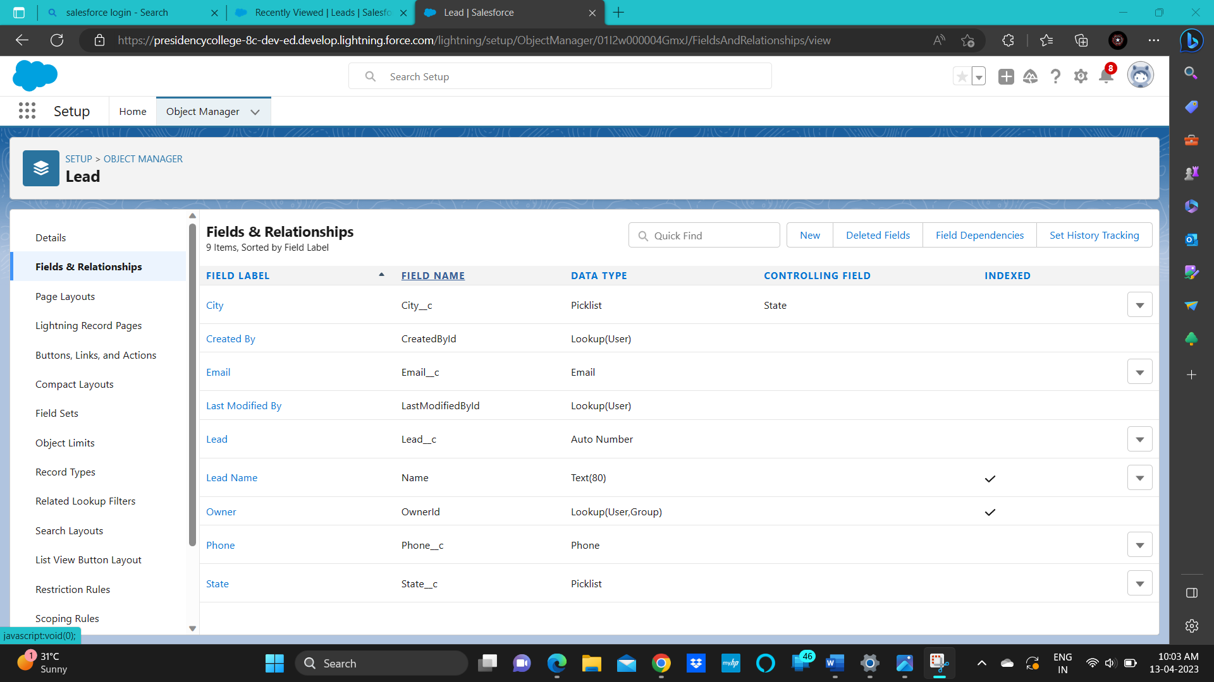

Object Lead and its field

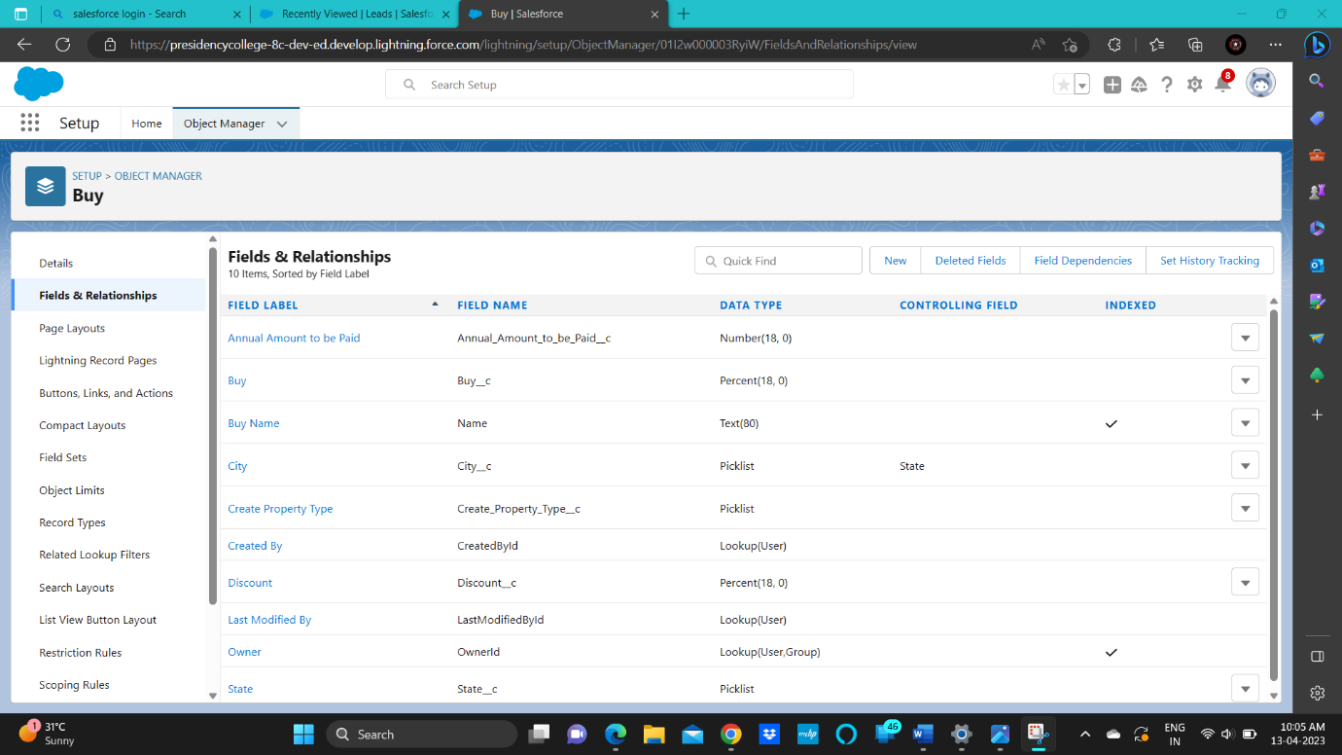

Object Buy and its field

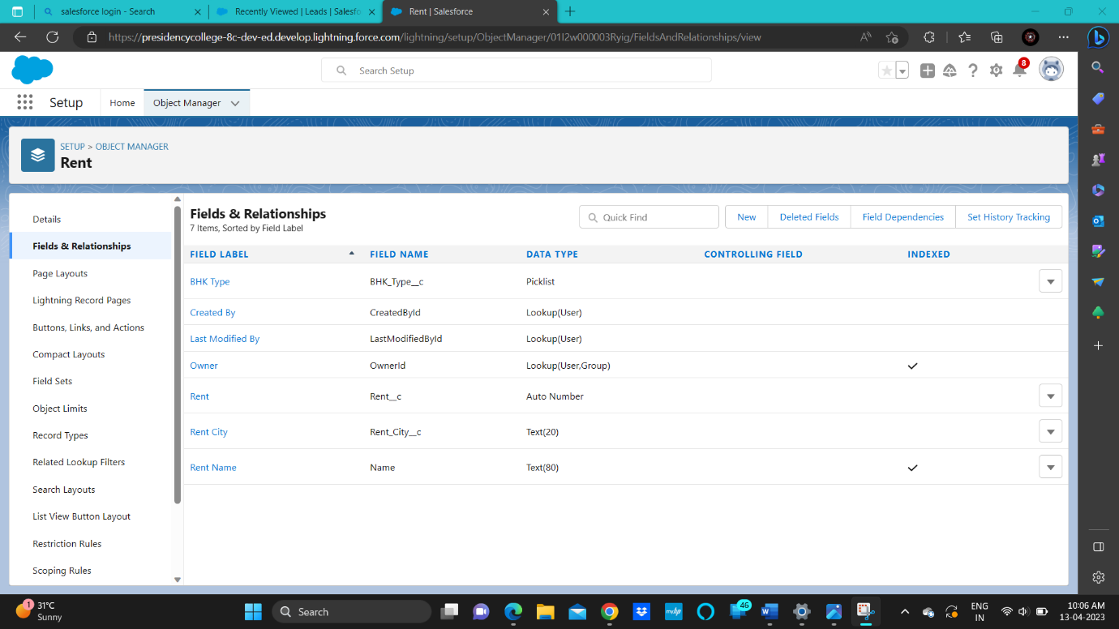

Object Rent and its field

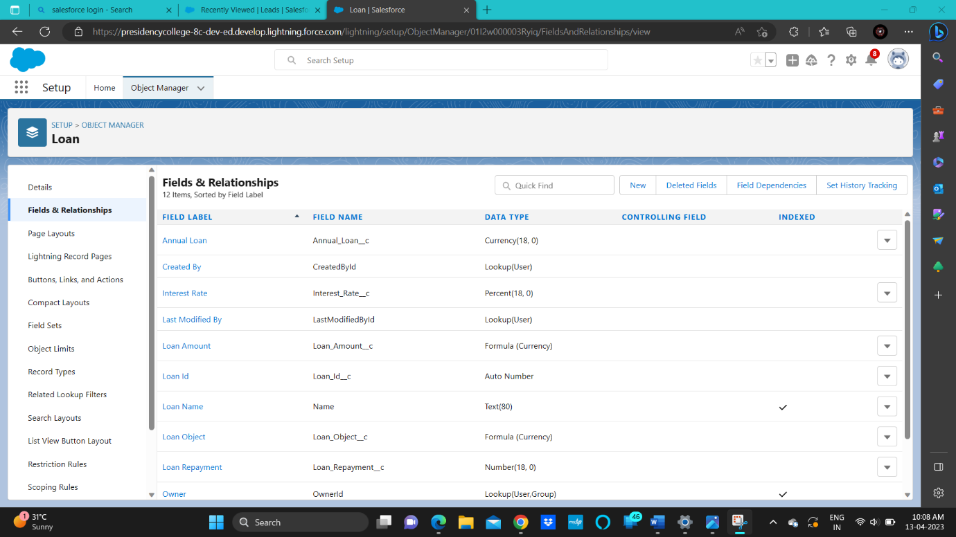

Object Loan and its field

4 Trailhead Profile Public URL

Team Lead- https://trailblazer.me/id/fleming221

Team Member 1- https://trailblazer.me/id/muralidharanb

Team Member 2- https://trailblazer.me/id/vasu905

Team Member 3- https://trailblazer.me/id/jprakash150

Advantages and Disadvantages

Advantages

1 Efficient Management: A property management application can automate many of the routine tasks involved in managing properties, such as rent collection, maintenance requests, lease renewals, and record-keeping. This can free up time for property managers to focus on more critical tasks.

2 Improved Communication: Property management applications can facilitate communication between landlords, tenants, and property managers. Tenants can submit maintenance requests or report issues quickly and easily, while landlords and managers can respond promptly and keep tenants informed about important updates.

3 Better Tenant Management: With a property management application, landlords and managers can access tenant information such as lease agreements, payment history, and maintenance requests, all in one place. This can help to identify high-performing tenants and those who may be struggling with payments or other issues.

4 Streamlined Finances: Property management applications can simplify rent collection, financial reporting, and accounting tasks. By automating these processes, property managers can reduce errors and save time while providing clear financial reports for property owners.

5 Improved Property Maintenance: A property management application can help to track and prioritize maintenance requests, allowing landlords and managers to address issues quickly and efficiently. This can improve tenant satisfaction and reduce the risk of long-term damage to the property.

6 Data Analytics: A property management application can generate data analytics reports that help property managers identify trends in tenant behavior, rent collections, maintenance requests, and other key performance indicators. This can help managers make data-driven decisions to improve the overall performance of the property.

Overall, a property management application can provide numerous benefits for property owners and managers, including streamlined operations, improved communication, and better tenant management.

Disadvantages

1 High Initial Cost: Implementing a property management application can be costly, particularly for smaller property management companies. The cost of purchasing and implementing the software, as well as training staff on its use, can be a significant investment.

2 Learning Curve: Property management applications can be complex and require some time to learn and get used to. Staff may need to spend significant time and effort learning the software, which can be a challenge for those who are not particularly tech-savvy.

3 Technical Issues: Like any software, property management applications may experience technical issues, such as bugs or glitches, which can disrupt operations and lead to downtime. This can be particularly problematic if the software is relied upon for critical tasks such as rent collection or maintenance management.

4 Security Concerns: Property management applications often contain sensitive information, such as tenant information and financial data, which can make them a target for cyberattacks. Without proper security measures in place, the application may be vulnerable to hacking or data breaches.

5 Limited Customization: While property management applications can offer many features and functions, they may not be customizable to fit the unique needs of every property management company. This can limit the ability of managers to tailor the software to their specific workflows and processes.

Applications

1 Rent Collection: Property management applications can automate rent collection, allowing landlords and property managers to easily track and receive rent payments from tenants.

2 Tenant Management: Property management applications can be used to manage tenant information, such as lease agreements, rental history, and maintenance requests. This can help landlords and managers stay organized and keep track of important tenant details.

3 Maintenance Management: Property management applications can be used to track maintenance requests, schedule repairs, and keep records of completed work. This can help to ensure that maintenance issues are addressed promptly, and the property is kept in good condition.

4 Accounting and Financial Management: Property management applications can be used to manage finances, including tracking income and expenses, generating financial reports, and processing payments to vendors.

5 Communication: Property management applications can facilitate communication between landlords, tenants, and property managers, allowing for easy communication and collaboration on important tasks and issues.

6 Marketing and Advertising: Property management applications can be used to market and advertise rental properties, including creating listings, managing inquiries, and scheduling showings.

7 Analytics and Reporting: Property management applications can be used to generate analytics and reports on a range of metrics, such as occupancy rates, rent collections, and maintenance trends. This data can be used to make informed decisions about property management strategies and investments.

Conclusion

Property management applications can offer a range of benefits for property owners and managers, from automating routine tasks and improving communication to providing valuable data insights and analytics. By using a property management application, property owners and managers can streamline operations, improve efficiency, and better manage their properties and tenants.

However, it is important to carefully weigh the advantages and disadvantages of different property management applications to find the best fit for a particular business. Some applications may offer more features and customization options, while others may be more cost-effective or easier to use. It is also important to consider security features and ensure that the chosen application can protect sensitive data and prevent cyberattacks.

Overall, property management applications can help property owners and managers to run their businesses more efficiently and effectively, while providing better service to tenants and ensuring the long-term success of their investments. By leveraging the latest technology and tools, property management companies can stay ahead of the competition and position themselves for growth in a rapidly changing market.

Future Scope

1. Artificial Intelligence: With the increasing use of artificial intelligence (AI) in various industries, property management applications may start to incorporate AI-powered features, such as chatbots for tenant communication and predictive analytics for maintenance and repair needs.
2. Smart Home Integration: As smart home technology becomes more popular, property management applications may start to integrate with smart home devices, such as thermostats and security systems, to provide a more seamless and connected living experience for tenants.
3. Blockchain Technology: Blockchain technology has the potential to revolutionize the way property transactions are managed and recorded. In the future, property management applications may start to incorporate blockchain technology to provide a more secure and transparent way of managing property transactions.
4. Sustainability and Energy Efficiency: With increasing focus on sustainability and energy efficiency, property management applications may start to incorporate features to help property managers and owners track and reduce energy usage, carbon emissions, and other environmental impacts.
5. Virtual Reality and Augmented Reality: Virtual reality and augmented reality technologies are already being used in the real estate industry to create virtual property tours and 3D models. In the future, property management applications may start to incorporate these technologies to provide a more immersive and interactive experience for tenants.

Overall, the future of property management applications is likely to be shaped by the continued adoption of new technologies, changing market conditions, and the evolving needs of property owners, managers, and tenants. As the industry continues to evolve, property management applications will need to adapt and innovate to stay ahead of the competition and meet the needs of their customers.